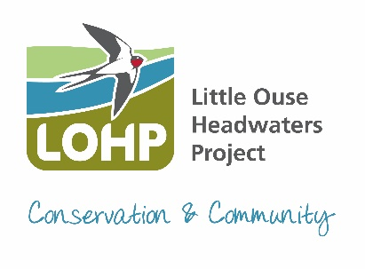
Little Ouse Headwaters Project
Ellie Beach – Conservation Manager
Thelnetham Windmill
Mill Road, Thelnetham
Diss, IP22 1JS
Email: ellie.beach@lohp.org.uk
Phone: 07919 912045
To find out more, become a member or donate visit www.lohp.org.uk

LOHP Annual Report for Annual Parish Council Meeting

2024 was another busy year for our volunteers undertaking practical conservation work and monitoring to manage our reserves. We have had a lot of new volunteers join us and we are working closely with local councils to provide corporate volunteering days.

Our practical conservation volunteers undertook the annual cut and clear of the grasslands at Garboldisham Churchyards. We cut the areas earlier than previous years to reduce the more vigorous plant species, allowing the delicate wildflowers to thrive. It is hoped that sheep will be able to graze the aftermath in the future.

Our monitoring and surveying volunteers run monthly Riverfly Monitoring, looking for special invertebrates on the Little Ouse River at Hinderclay Fen and Scarfe Meadows to keep a check on the water quality. Bird ringing continues annually on Hinderclay Fen.

The Shorthorn Cattle have been doing a great job grazing our reserves over the last year, they seem to get into places where the Redpoll were not as keen. We were also joined by a flock of Dorset Downs on Reeves Meadows. Sadly, there were a couple of incidents with dogs off leads and out of control getting in with the sheep. People forget it is a legal requirement to keep your dog under control/on a lead when in areas with livestock. At this time of year there are also lots of ground nesting birds. The livestock will all be back later this year.

We are into year 3 of providing supplementary feeding stations for Turtle Doves, as part of the RSPB Operation Turtle Dove Project. We have feeding stations set up with two local landowners and on our reserve Reeves Meadows. Fingers crossed this will be the year that Turtle Doves return to the area to breed. If you think you might have an area suitable for Turtle Doves, then please get in touch.

Improving access - Norfolk County Council is in the early design stages of constructing a new footbridge over the Little Ouse, connecting Blo’ Norton Footpath15 in Norfolk with Hinderclay Footpath18 in Suffolk. More information will be circulated by them as the process continues.

We are holding our first Spring Plant and Craft Fair 2025 on Sunday 13th April on The Frith, in South Lopham. After the success of the first art exhibition; our second Art Exhibition ‘Art in Nature’ will be held on 24th and 25th August; this year at Hinderclay Village Hall. We will be attending lots of events locally this year so do pop along and say hello or join us on one of our guided walks which can be found listed on our website. Hope to see you there.

Ellie Beach
LOHP Conservation Manager April 2025

