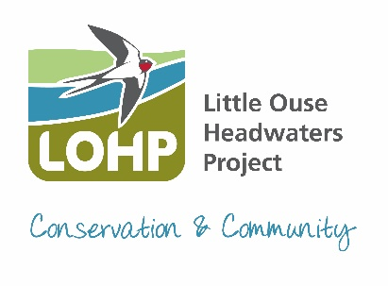
Little Ouse Headwaters Project
Ellie Beach – Conservation Manager
Thelnetham Windmill
Mill Road, Thelnetham
Diss, IP22 1JS
Email: ellie.beach@lohp.org.uk
Phone: 07919 912045
To find out more, become a member or donate visit www.lohp.org.uk

LOHP Annual Report for Annual Parish Council Meeting

The wet weather over the last few months has made managing our sites for wildlife and people much more challenging along with the loss of local parking areas. But we have managed to adapt and adjust to the changing conditions and completed all our winter fenland and woodland management with the help of volunteers and specialist contractors.

Last year we were involved with several small community projects with local landowners and parishes. From cutting and clearing the grasslands at Garboldisham Churchyards, to planting hedgerows at Thelnetham Windmill, to helping Blo’ Norton Parish care for newly planted trees and much more.

We have seen an increase in the number of people wanting to join us to volunteer. We have hosted local groups and been joined by volunteers from Norfolk Youth Justice and Lapwing Education, who cater for young people who need more support. We are also working closely with local councils to provide corporate volunteering days.

Last summer saw us say goodbye to the familiar Redpoll Cattle that have been grazing our sites for a number of years as our grazier retired, and we welcomed two new graziers, one with Shorthorn Cattle, the other with sheep. Look out for them later in the year.

If you joined us at our AGM back in December, you would have learnt all about the Mink Free East Anglian Project that we are part of, to help protect our endangered Water Voles. Good news is that we have not caught any Mink for quite a while, or had any positive sighting, so fingers crossed.

Our volunteers are not only involved in practical conservation work, but they also carry out monitoring and surveying work. We run monthly Riverfly Monitoring on the river at Hinderclay Fen and Scarfe Meadows looking for special invertebrates to keep a check on the water quality, along with bird ringing that continues annually on Hinderclay Fen. Water levels are also recorded across our sites every month and we are undertaking a Water Vole survey on Scarfe Meadows as part of a larger local survey.

This is our second year of providing supplementary feeding stations for Turtle Doves, as part of the RSPB Operation Turtle Dove Project. Last year we worked with 3 local landowners to set up these special feeding sites. We are working with two of them again this year and are trying a different area on one of our sites. Hopefully before long we may see more breeding Turtle Doves return to the area. If you think you might have an area suitable for Turtle Doves, then get in touch.

We are attending lots of events locally this year so do pop along and say hello or join us on one of our guided walks which can be found listed on our website.

Ellie Beach
LOHP Conservation Manager April 2024

